Marching Crawfish invade a SC yard after Michael: ‘Oh my gosh, they were everywhere’
BY NOAH FEIT
nfeit@thestate.com
As Tropical Storm Michael made its way across South Carolina Thursday morning, its heavy rain and powerful wind left several things in its wake.
Uprooted trees, downed powerlines and flooded roads were among the more common impacts of the storm.
A Columbia-area family had to deal with something more unusual — an infestation of crawfish.
Peggy Breeland told The State that crawfish were “crawling all over the yard” of her waterfront home on Lake Murray.
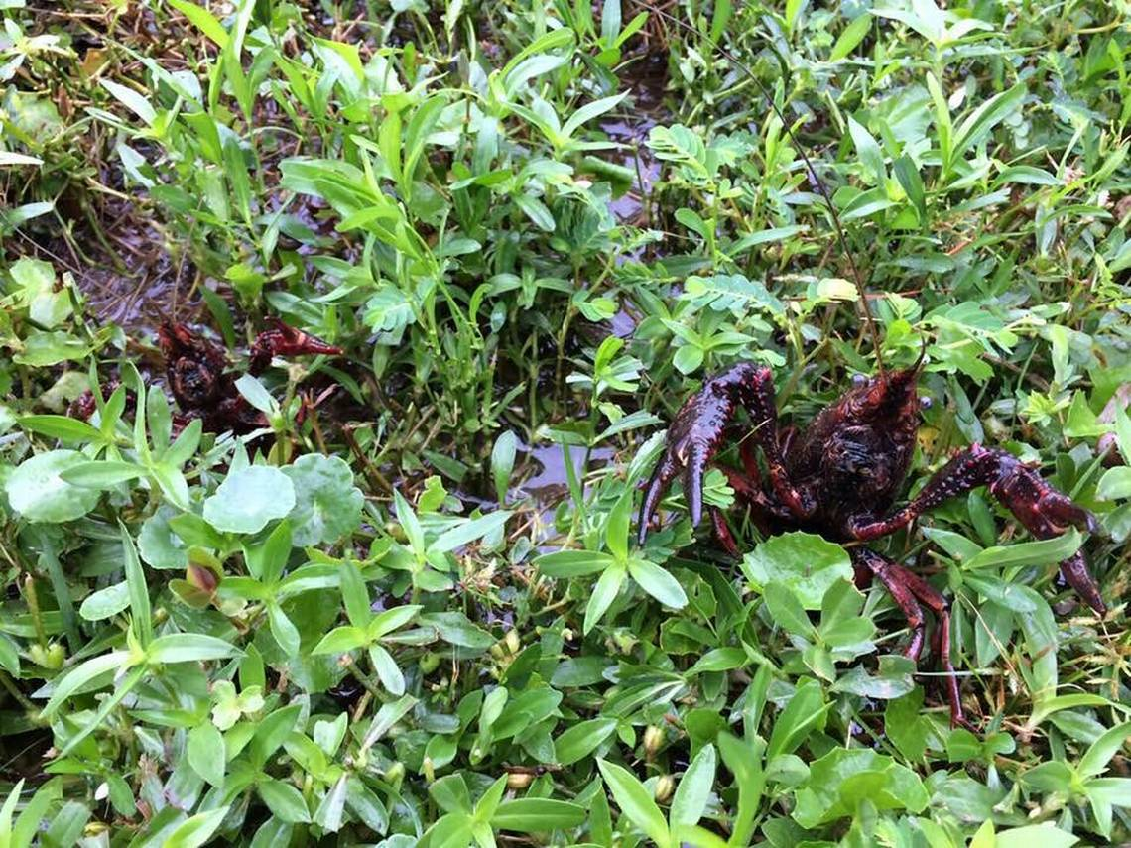
Crawfish infested a yard in Lake Murray following Hurricane Michael.
“I was amazed,” Breeland said about seeing more than three dozen crawfish in her yard, and at least another dozen in her next-door neighbor’s yard.
The crawfish were first discovered before 6 a.m. by Breeland’s husband when he went to take their dog for a walk, telling her he “saw some.” In two hours, “some” rapidly grew, but Breeland was skeptical when her husband and son told her they were all over the yard. She said they like pulling her leg, but seeing made her a believer.
“Oh my gosh, they were everywhere,” Breeland said
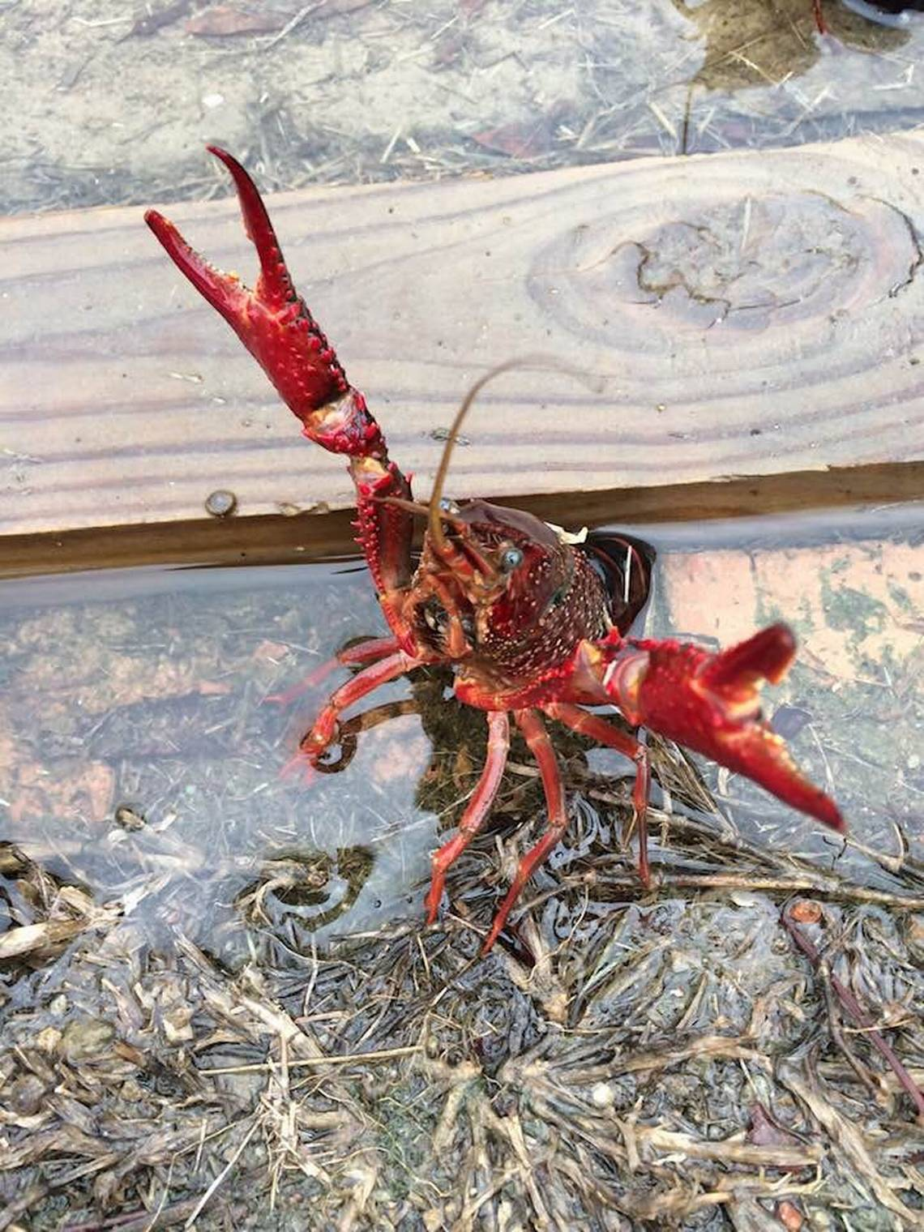
Crawfish infested a yard in Lake Murray following Hurricane Michael.
Anderson Breeland
“They were in the side yard, the front yard, the back yard. I was totally shocked,” Breeland said.
The self-proclaimed nature lover said she was not going to interfere with the crawfish. But Breeland admitted she was afraid they would die and she would have to go around her yard picking up their shell-covered corpses, like she has to pick up pine cones.
That fear was allayed when the sun came out, and Breeland said the crawfish “marched back to the lake.”
Well, most of them.
She said a few took advantage of her open garage door and were making themselves at home near her car.
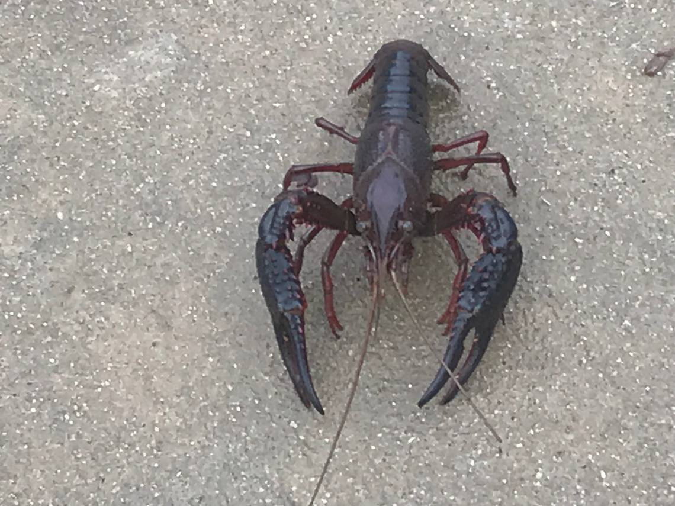
Crawfish infested a yard in Lake Murray following Hurricane Michael.
Anderson Breeland
Even though she knew it was a crawfish, Breeland said she initially mistook the multiple crawfish in the garage for another creature.
“I saw it crawling and thought it was a spider, a tarantula, it’s about the same size,” Breeland said. “It scared the daylights out of me.”
She said her husband ushered the crawfish out of the garage. In spite of being startled, Breeland did some exploring along the shoreline of her neighbor’s yard and said she discovered crawfish nests “all around.”
This was something of a surprise, because Breeland and her neighbors had not seen many crawfish in their yards previously, save for one she said she found by her mailbox, but thought it was something left there by a cat or dog. More common wildlife include copperhead snakes, water moccasins and deer, Breeland said.
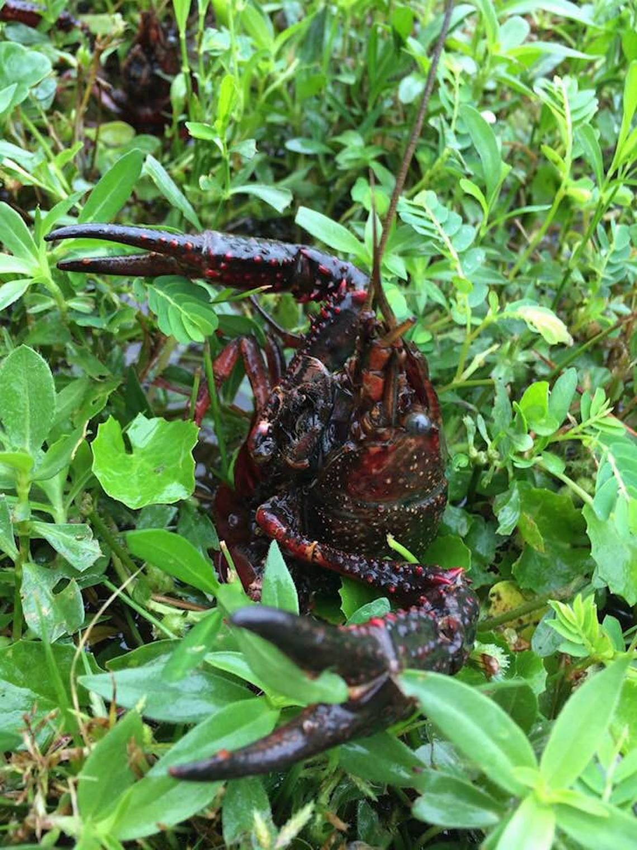
Crawfish infested a yard in Lake Murray following Hurricane Michael.
Anderson Breeland
It also helps explain the variety of sizes of crawfish she encountered in her yard. Breeland reported that most were in the 4-5 inch range, but there were a few that were more than 7 inches in length. There were also several smaller ones she determined to be babies.
Although Breeland has not come across many crawfish before Hurricane Michael, they are found in Lake Murray. And a powerful storm could stir them up.
Following Hurricane Irma hitting the Columbia area in 2017, a Charleston manposted a picture of a cooler filled with crawfish he caught. He wrote “After a saltwater bath they made a good steam pot.”
Even if the crawfish in her yard had not scurried away, Breeland said she was not planning on cooking them in a Low Country Boil and serving them to family and friends.
“We joked about cooking them. I’m a big seafood eater, but I never took to the taste of crawfish,” Breeland said. “After the next storm we have, maybe we’ll give it a try. ... But they’re not hurting us, so we’re trying to leave them be.”
